Midterm

1. (B) 4 10 16 because it is incrementing by even numbers due to the for loop
2. (A) Dog fish cat

3. What is the output of the program segment below?   
  
int num1 = 500;   
int num2 = 200;   
int num3 = 300;   
int average = num1 + num2 + num3 / 3; //Division is done first  
System.out.println(average);

(A) 333  
(B) 333.333333333333  
(C) 334

(D) 800 <- Answer  
(E) Syntax Error

4. Consider the following code segment.  
  
double a = 10;

double b = 3.5;

int c = (int) (a / b);

int d = (int) a / (int) b;

int e = c – d;

What is the value of the variable e?

1. -1 <- Answer
2. -0.5
3. 0
4. 0.5
5. 1

5. Consider the following boolean expression.   
  
boolean result = !(a <= b && c != d)

Which of the following options is equivalent to result?

1. !(a <= b) && !(c != d)
2. !(d != c && b >= a)// Flipped what was given in result
3. a > b || c == d // Distributing the (!) flips <= to > and != to == and && to ||
4. I only
5. II only
6. III only
7. I and II
8. II and III<- Answer

6. What value is returned from Math.pow(3, 2)?

1. 5.0
2. 6.0
3. 7.0
4. 8.0
5. 9.0 <- Answer

7. Consider the following method.   
  
public static void changeArrays(int[] arr1, int[] arr2){

arr1 = arr2; // Set arr 1 to arr 2

arr1[3] = 3;

} // When method is over, a is still array []a

What are the values of a and b after running the following code?

int[] a = {1, 2, 3, 4, 5};

int[] b = {6, 7, 8, 9, 10};

changeArrays(a, b);

a b

1. {1, 2, 3, 4, 5} {6, 7, 8, 3, 10}<- Answer
2. {1, 2, 3, 4, 5} {6, 7, 8, 9, 10}
3. {6, 7, 3, 9, 10} {6, 7, 8, 9, 10}
4. {6, 7, 8, 3, 10} {6, 7, 8, 3, 10}
5. {6, 7, 8, 3, 10} {6, 7, 8, 9, 10}

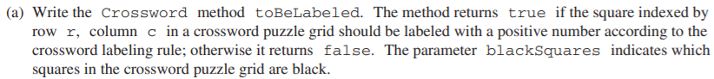

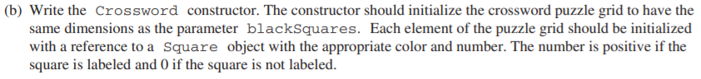

Last Week’s material is on the midterm, this weeks material is on the final